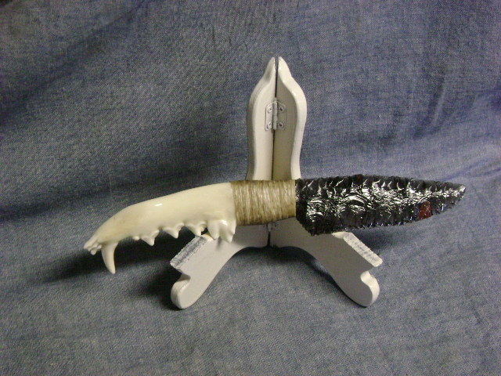
Blade: Midnight Lace Obsidian from Oregon
Handle: Coyote Jawbone
Item: TV14
Price: $85.00

