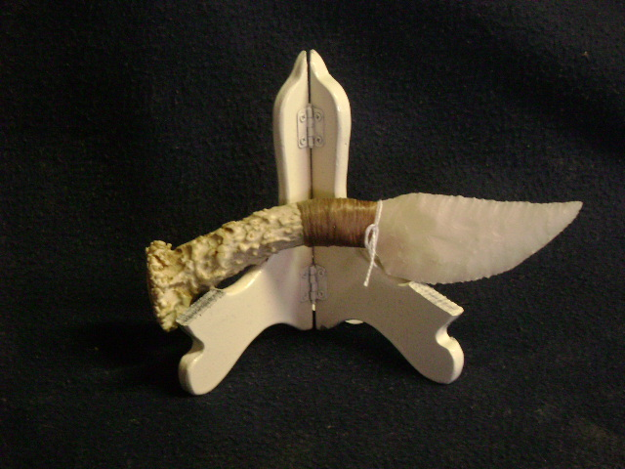
Blade: Novaculite Flint from Arkansas
Handle: Deer Antler
Item: TV15

Price: $65.00

