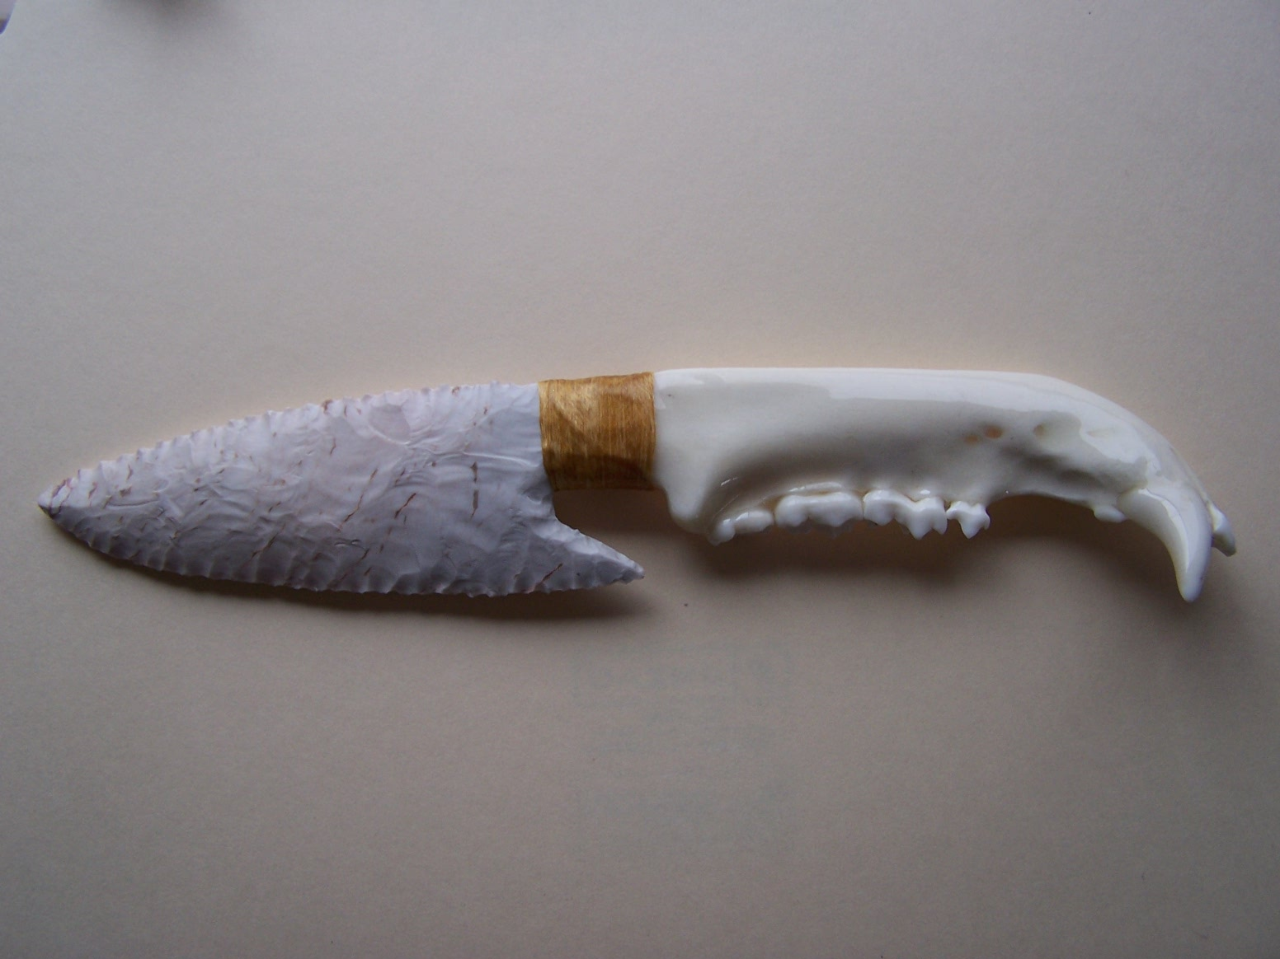
- Blade: Keokuk Flint from Oklahoma
- Handle: Bear Jaw Bone
- Item #: J002
- Price: $200.00

