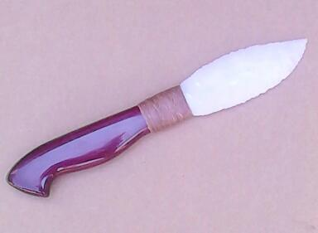
- Blade: Novaculite
- Handle: Purpleheart Wood from South America
- Item #: TV 19
- Price: $120.00

