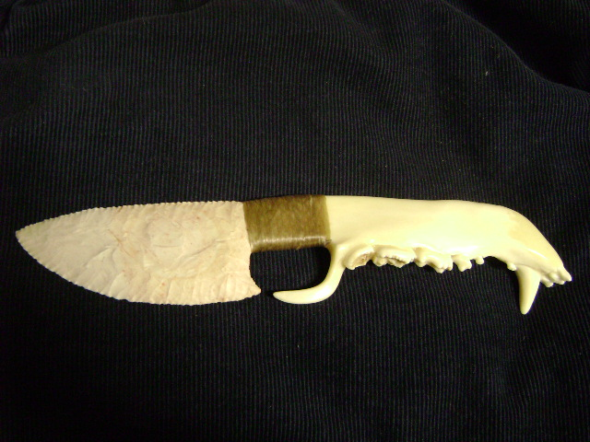
- Blade: Keokuk Flint from Oklahoma
- Handle: Black Bear Jaw Bone
- Item #: 628
- Price: $210.00

