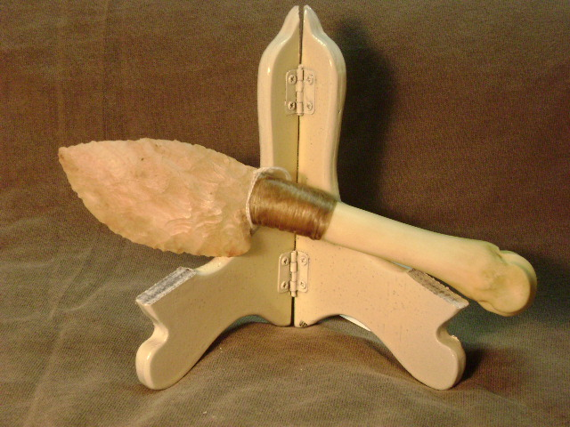
- Blade: Burlington flint
- Handle: Deer leg bone
- Item #: 455
- Price: $90.00

