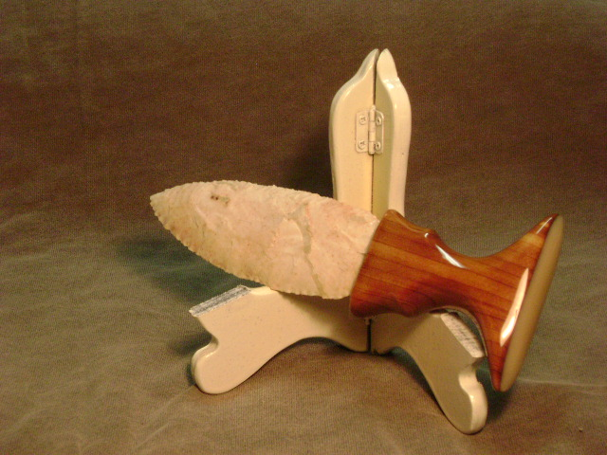
- Blade: Burlington flint from Missouri
- Handle: Ohio cedar with elk bone cap
- Item #: 444
- Price: $120.00
- Push Dagger

