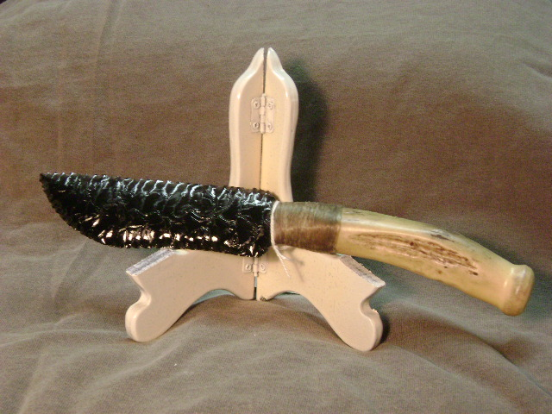
- Blade: Manmade black glass
- Handle: Deer antler
- Item #: 401
- Price: $85.00

