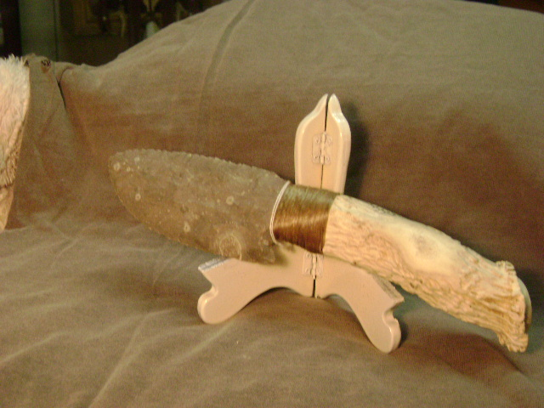
- Blade: Texas Flint
- Handle: Very Large Deer Antler
- Item #: 398
- Price: $125.00

