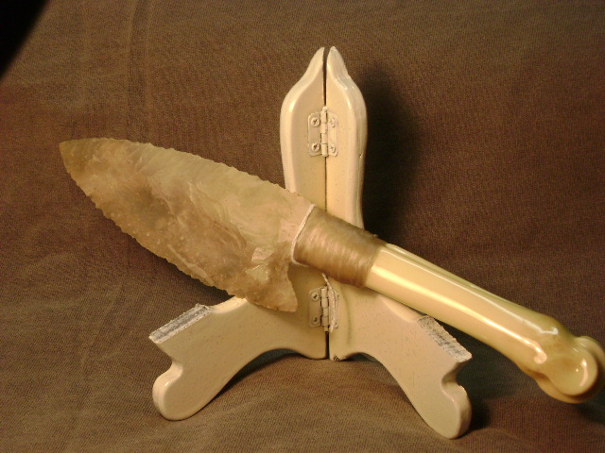
- Blade: Texas flint
- Handle: Deer leg bone
- Item #: 368
- Price: $90.00

