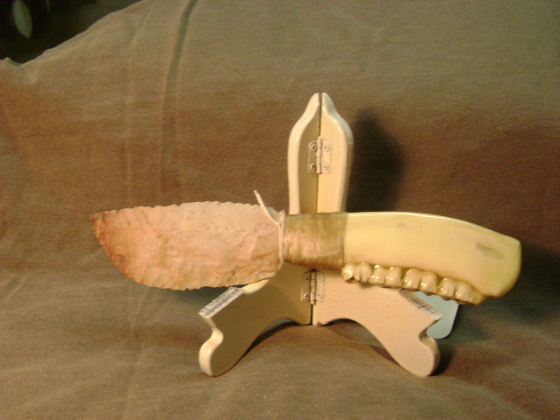
- Blade: Flint Ridge flint
- Handle: Deer jawbone
- Item #: 344
- Price: $110

