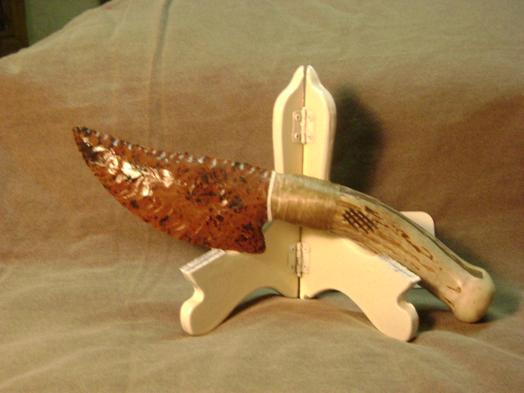
- Blade: Mahogany obsidian from Oregon
- Handle: Deer antler
- Item #: 300
- Price: $92.00

