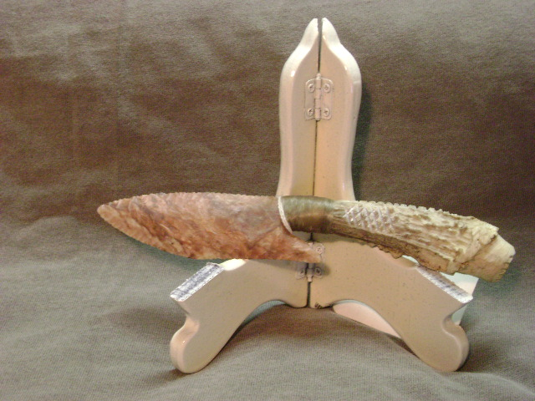
- Blade: Burlington Flint from Missouri
- Handle: Deer antler
- Item #: 274
- Price: $90.00

