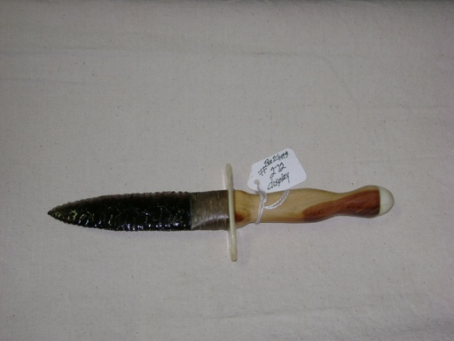
- Blade: Smoky Gray Obsidian from Oregon
- Handle: Ohio Cedar with Deer Bone Cap and Cow Bone Hilt
- Item #: 272
- Price: $150.00

