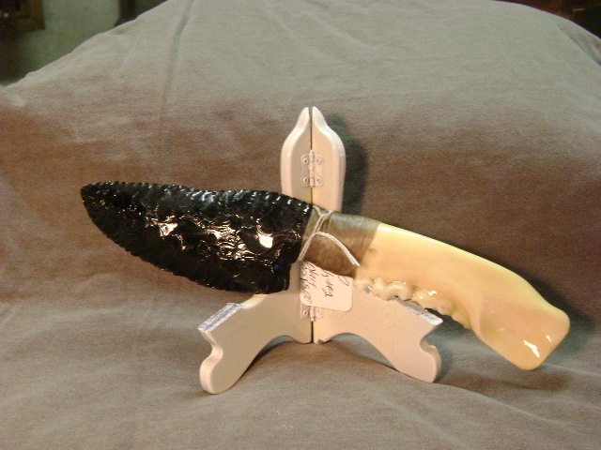
- Blade: Smoky gray obsidian from Oregon
- Handle: Black bear jaw bone
- Item #: 250
- Price: $125.00

