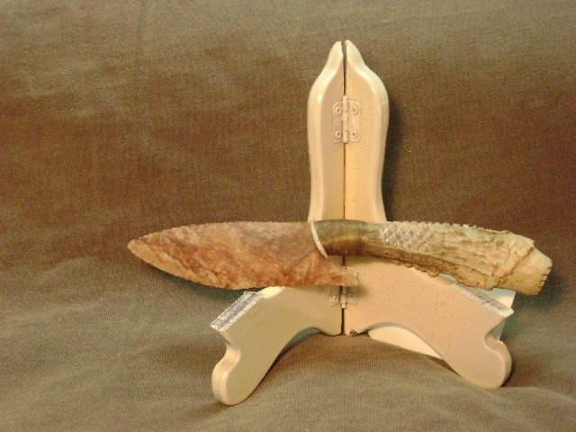
- Blade: Burlington flint from Missouri
- Handle: Deer antler
- Item #: 226
- Price: $90.00

