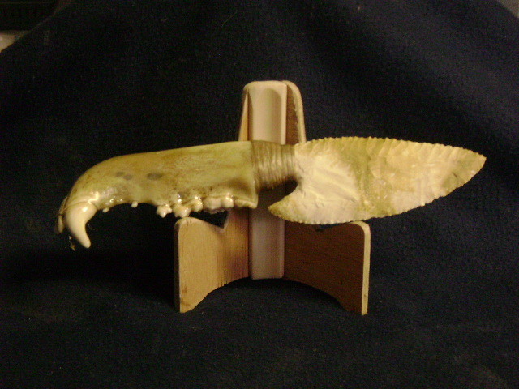
Blade: Burlington Flint from Missouri
Handle: Large Black Bear Jawbone
Item: 584
Price: $200.00

