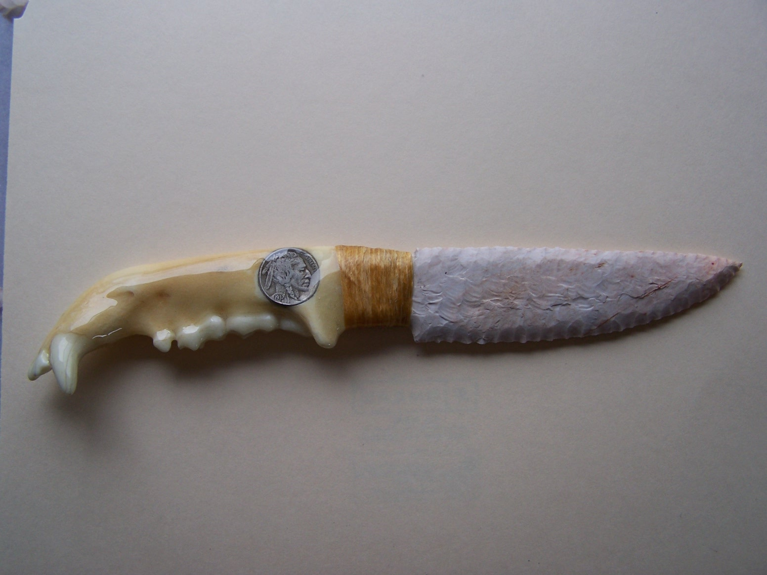
- Blade: Keokuk Flint from Oklahoma
- Handle: Bear Jaw Bone
- Item #: J001
- Price: $175.00

